Tutorial 2 – Camera Movement

In this tutorial I will provide a method of creating first person perspective camera movement. This is a continuation of my first tutorial on player movement

1. Start by reopening the PlayerContoller script from the previous tutorial that should be on your player object.
2. We will now create a few new variables. First, we will make a reference to the camera which we will view from, to do this we will make a private camera reference and call it cam for short. We will also make a float called lookSensitivity and make it equal to 3f.

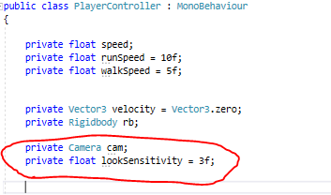

1. Then we will make two Vector3 variables called rotation and cameraRotation, we will also set these to both we equal to (0,0,0) by typing = Vector3.zero;

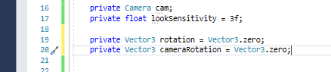

1. Now that we have made our variables we need to collect the inputs of the players mouse, we can do this by using two floats in the void update and naming them yRot and xRot this will hold their respective rotations from the mouse movements along the x and y axis.

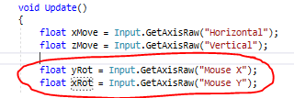

1. Next, we shall make two Vector3 variables called _rotation and_ cameraRotation, these will take the xRot and yRot floats and multiply them by the lookSensitivity. Then below that we will put a call to a void we will make next called PerformRotation.

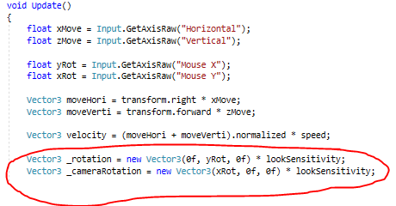

1. Now we will convert out rotation and cameraRotation to equal the new _­rotation and _cameraRotation.

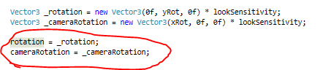

1. After calling the PerformRotation nothing will happen so we should now create that void. Inside this void we will first put a reference to the rigidbody so that it rotates with the camera along the y axis but not the x axis.

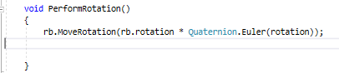

1. Now to make the camera move along the x axis we need to only move the camera so we will just use a transform.Rotate function that uses the x axis input.

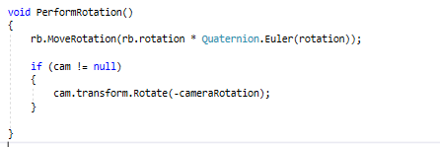

1. Finally, we will finish off by locking the cursor to the centre of the screen so we can move the mouse around freely without it wandering off screen. To do this all we need to make is a simple void called awake and inside it use the code Cursor.lockstate and set it to locked.

